Olympic National Park
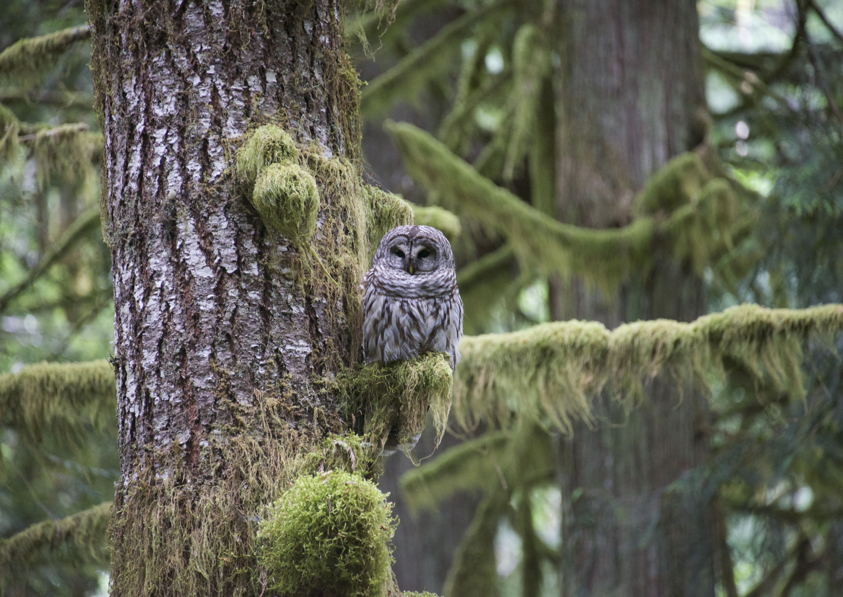
Welcome Explorer! You are about to embark on an awe-inspiring adventure through Olympic National Park. During your journey you will…

Learn about the geography and history of the Olympic National Park and

Explore different ecosystems and investigate the relationships between plants, animals and their environmental.

Study the three B’s of Olympic National Park: birds, bugs and botany.

Collect data and engage in a field experiments.

Use all your senses to write about your surroundings.

Let’s get started! We have a lot of exploring to do.

Vocabulary Check: Geography- The study of the earth and its features. Ecosystem- A community of living things and their environment. Botany- The science or study of plants

Olympic National Park is located in the state of Washington in the Olympic Peninsula. A peninsula is piece of land surrounded almost entirely by water. Find the Olympic Peninsula on your trip map and run your finger around it. Notice where your finger touches water and where it touches land. What bodies of water surround the Olympic Peninsula ________________, _________________, _______________, _________________________
Today, when you look around the Olympic Peninsula you will see roads, cars, boats and bridges. It may even look similar to the town where you live. But, if you traveled back in time you would see a very different place.

Traveling back about 165 years, the Olympic Peninsula was a vast uncharted wilderness. The peninsula, like much of the west, had yet to be fully explored or settled upon. There were no houses, roads or services and people who traveled here got around on foot, by horse carriages or canoes.

Around that time, 1846 to be exact, The United States settled the claim for the Oregon Territory, which included the Olympic Peninsula. Lots of countries wanted this land, Great Britain, Spain and Russia. But, it was particularly important to the United States because with the acquisition of the Oregon Territory the United States stretched from coast to coast- from “sea to shining sea”.

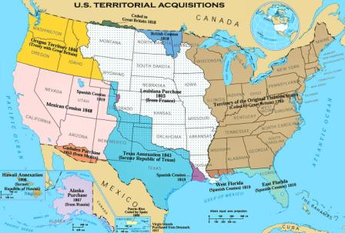
Find your home state on this map. What year did your state become part of the United States of America? If you wanted to travel from your home state to the Oregon territory, you would likely travel in a wagon train. Draw line, indicating the most direct route from your home state to the farthest point of the Oregon territory.
In order to strengthen the claim on the Oregon Territory, the government needed people to move out west to settle and develop the land. The government created a program to entice people to do this very hard job. The program was called the Homestead Act and it worked!
Imagine you were a homesteader in the Olympic Peninsula. In order to claim your land, you would need to clear the land, build a home and grow crops.

List of supplies:
Most Homesteaders brought the following items on their journey. What additional items would you need to build your homestead?

Life wasn’t easy for the homesteaders. But, through hard work and determination, the homesteaders built farms, roads, post offices, schools and created communities that would set the frame work for what Olympic Peninsula is today.

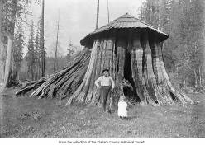

Cedar tree stump hut used as Elwha Post Office ca. 190
Vocabulary Check: peninsula- a piece of land almost surrounded by water or projecting out into a body of water. Wagon train- a caravan or train of covered organized by settlers in North America. Homestead Act- a special act of Congress (1862) that made public lands available to settlers, usually 160 acres to be used as farms. Homesteaders- a settler under the Homestead Act
The homesteaders were not the only inhabitants of the Olympic Peninsula and they were not the first. Traveling back even further in time, about 3,000 years, tribes of the peninsulas indigenous people lived here.
Graphic Bubble (family finding basket): Family from Florida discovered a 2,900 year old artifact while hiking on hurricane ridge. Keep your eyes out during your hikes in Olympic National Park. You never know what you may find.

Archeological evidence and oral stories, passed down through generations, have taught us a lot about them.

These are some artifacts that have been found on the Olympic Peninsula. Can you match the artifacts with the resources the indigenous people used to make them?

Graphic: Images of artifacts with description of what they are.
Artifact Resource
Canoe Hallow cedar tree
Bow branch
Basket bark and roots
Comb fish bone
Bark pounder whale bone
Jewelry shells
Coat seal ski

Do you want to see these artifacts first hand? Would you like to actually walk through a replica of a 600 year old long house and imagine what life was like for the indigenous people of Olympic Peninsula? Visit the Makah Museum in Neah Bay. There are hundreds of fascinating artifacts to see, touch and learn about.

Signature box for museum visit.

Graphic: Hunter with spear and giant mastodon.
During the ice age the Olympic Peninsula looked a lot different. Ice sheets covered much of the area and so did giant mammoths, large cats and wolves. In 1977 remains of a great mastodon, possibly were unearthed in Olympic National Park. Embedded in one of the mastodon’s ribs was a broken piece of bone that resembled a spear point! The spear point was dated 13,800 years old. Wow!

Imagine you were that hunter and that it was you and your spear versus a giant mastodon. You won’t find any mastodons as you hike around the park today but if you use your imagination, you could have a pretty spectacular mastodon adventure.

Vocabulary Check: Indigenous- native or occurring originally. Archeological (Archeology)- the study of human past using material remains. Artifact- an object made or used by a human being.
Ecosystems of Olympic National Park

An ecosystem is a system formed by the interaction of a community a living organisms and their physical environment
Graphic:
Living organisms Physical environment
Plants, animals, microbes, - air, water, minerals and soil.

In Olympic National Park, there are several distinctly different ecosystems. These ecosystems can be found on the coasts, in forests and within the high mountains.

Coastal Ecosystem

Olympic National Park protects over 70 miles of rugged coast on which you will find great waves, rocky beaches, giant drift logs, wondrous tidepools, stunning sea stacks and caves. Which of these coastal beaches will you and your family visit? What are you most excited to see?

Graphic: Coastal section highlighting: Shi Shi Beach, Cape Alava, Riato Beach, Ruby Beach, Kalaloch. Including a bit about each beach.

One best ways to study the costal ecosystem of Olympic National Park is to explore one of its many tidal pools. Tidepools are created when the ocean recedes and uncovers shallow pools left behind in rock depressions and crevices.
One square foot in a tidal pool can be home to thousands of living organisms.

On your coastal exploration, see how many of these living organisms you can find in and around tidal pools.

Graphic: Tidepool Bingo Include the following
1. Ribbed Limpet: Eat algae that they scrape off moist rocks and can live weeks without water. 2 Periwinkles: can survive almost a month without getting wet. 3 Sea urchins dig their homes into rocks underwater. They eat kelp in the deep waters. 4 Blue mussels hold onto rocks with byssal threads. Their shells protect their soft bodies from the sun. 5 Ochre sea stars clear the way for other creatures by eating mussels in higher zones. They move from place to place underwater. 6 Acorn barnacles use their feet, called cilia to reach for food. They close up when the tide is out. 7. Nudibranch has feather-like gills on their backs. You may only find these at very low tide or during a full moon. 8. Giant green anemones close up; cover their green prey-stunning stingers in order to stay moist when tide is out.

Did you know: Biologist study tidepools to gain important information about the oceans health and our environment. There are four sections or tide zones they study;

Graphic: Splash zone (snails), High Tide Zone (bivalves), Mid Tide Zone, (sea stars) Low Tide Zone (Nudibranch). You can tell which zone the tide has uncovered by looking at the living organisms found in the tidepools. Which Tidal Zones did you explore?

Forests

All forests have lots of trees, but did you know there are different types of forests? Ecologists often classify forests by their elevation zone and amount of rainfall. Within Olympic National Park there are five distinct forests each with its own ecosystem.

Graphic: Mountain with n/s/e/w show different forests with description.

Trail Markers: Hiking is the best way to explore the forests of Olympic National Park. Check out these hikes and investigate their unique ecosystems.

Costal Forests: These forests are found along the oceans edge and are dense with lush ferns, shrubs and a vast canopy. * TRAIL MARKERS Graphic with trail names Coastal Forest Nature Trail near Kalaoch, Rialto Beach Trail 1.5 miles, Second Beach trail .7 mile hike, .3 miles loop to James Pond.

Lowland Old Growth Forests: Olympic National Park’s lowland forests are home to ancient trees some bigger than 30 stories tall and wider than two parking spaces. Trail marker graphic: Marymere Falls Trail (start at storm king ranger station. 1.8 miles round trip Lake Crescent)

Temperate Rain Forests: Temperate Rainforest exists within the same elevation zone as the Lowland Old Growth Forests. Many of the trees and plants found in the lowland forests will also be found within the rain forest. What makes the ecosystems different? The amount of rain. Twelve to fourteen feet of rain fall in Olympic’s rain forests each year and create the perfect conditions for the rain forests lush understory.

Hoh Rainforest’s Hall of Mosses Trail .8 miles hike 1.2 miles Spruce Nature Trail.

Montane Forests: As you climb to the higher elevations of Olympic National Park you will pass through the montane forests. With higher elevation, come harsher conditions. Cold temperatures, strong winds and forest fires contribute to this less dense but equally rich ecosystem.

Trail marker: Heart O’ the Forest -4.6 miles round trip.

Subalpine Forests: As you continue to climb in elevation, hurricane force winds and harshly cold climates create conditions too difficult for trees to grow. The transition from montane to subalpine and then alpine zones can be noted by the gradual transformation of land and tree-scape. Trees in the subalpine forest are tough, often mangled and misshapen, they withstand a lot those trees.

Hurricane Ridge, Hurricane Hill Trail 1.6 miles one way, Meadow Loop Trail .25-.5 miles.

Graphic: Trail Marker Ecosystems living organism match up:

Vocabulary Check: alpine- the very high region of mountains where trees can no longer grow. Subalpine- the area just below the tree line.

Mountain Ecosystem
Stretching from the treeline to the highest peaks in Olympic National Park is the alpine zone. This mountain habitat with freezing temperatures, abundant snowfall and harsh winds would be hard for humans to endure. Yet, the wildflowers and wildlife that call this zone home and are well adapted for life here.

Mountain ecosystem Bingo

Golden Eagle Grey- Crowned rosy finch, horned lark, Olympic chipmunk
Olympic marmot, Raven, Flett’s violet, Piper’s bellflower, Scalloped Onion, Smooth Douglasia, Spreading Phlox

Birding, Bugs and Botany

Olympic National is home to over 300 species of birds. In every climate and elevation of the park you will find birds with unique features perfectly suited for their habitat. As go bird watching through Olympic National Park, look out for key features help identify birds and learn about how each bird adapts and thrives in its environment.

Draw in these key bird features:
Feathers: only birds have feathers
Field marks: patterns and color markings on feathers
Wings
Tail
Feet with four toes
Beak in a shape that helps the bird get and eat food
Eyes with three eyelids
Ears under the feathers at the sides of their head

Bird Registry: Keep an eye out for these common Olympic Peninsula birds.

How many birds can you find?
Northern Spotted owl
Bald Eagle
Red-breasted sapsucker
Black turnstone
Pine siskin
Red- tailed hawk
Great Blue Heron
Black Oystercatcher
Northern Flicker
Male Sooty grouse
Rhinoceros Auklet
Trumpeter swan

Bugs: On our planet, bugs out number people 200 million to 1. There are a lot of bugs out there and as you explore Olympic National Park you are bound to run into more than a few. Most people use the word bug to describe every creepy crawly thing found on the ground and flying through the air. However, scientists know, and now you will too, that bugs and most other creepy crawly things on land and sea fall into a larger category of species known as ARTHROPODS.

Arthropods come in all different shapes and sizes and live in every nook can cranny of our planet. Although they can look very different all arthropods have these four things in common.
Graphic
They are invertebrates - they have no backbone.
They have exoskeletons – they have an outside skeleton.
They have pairs of jointed appendages-
They have segmented body parts- most arthropods have three body parts: head, thorax and abdomen.

As you explore Olympic National Park, you will find three major categories of arthropods. Graphic with each class – shadow pictures

Chelicerata (che- li- ser- ata): This group is categorized by their chelicerae, or mouthparts. This group of arthropods all have pinchers in the front of their mouth. Horseshoe crabs and spiders are both chelicerates.

Atelocerata (at – lo- ser- ata) This is the largest group of arthropods. All insects including, beetles, butterflies, and ants are part of this group. Millipedes and centipedes are arthropods that fall into this category too.

Crustacea (crust- a – she- a) You are most likely to find this category of arthropods on your costal exploration of Olympic National Park. Sowbugs, lobsters, crabs, and barnacles are all crustacea.

Arthropod Field Study: As you explore Olympic National Park keep your eyes out for Arthropods. Once you find one put your scientific observation skills to work.

Check list graphic: Picture box for drawings lines for notes
- Do some quick counting. Note bumber of body segments, number of legs and number of wings if any.
- Look at the overall body plan. Record shapes, sizes, patterns and colors,
- Focus on structural details: Are their antennae, legs, wings, any distinctive features.
- Listen for sounds, sniff for odors.
- Collect as much behavioral data as possible. What was the arthropod doing when you found him? Where was it located? Is it feeding? Is there evidence of its habitat?

Slugs and snails belong to a family of animals known as gastropods. You will find lots of gastropods in Olympic National Park the biggest by far being the banana slug. Banana slugs are the second largest slugs in the world and can live for as long as seven years. These guys have a big fan following and it’s no surprise why.

Botany

How many shades of green can you find in Olympic National Park? From the moss-covered floors, to skyscraping treetops there so many different types of plants that you could possible find every shade of green within the color spectrum.

These are four common plants you will find in Olympic National Park. See if you can find at least one of each. Look at their leaves, branches, bark, flowers and seeds. Compare the color, smell, shape and texture of each.

Graphic of a tree and a fallen tree

The Forest Food Factory
Plants are producers, which means they produce or make their own food. They do this by using the suns energy to remove carbon dioxide from the air. That carbon dioxide is mixed with water from the soil to create sugar. Pretty neat huh? How would you like to be able to produce your own candy just by soaking up the suns rays? The sugar making process (conversion of suns energy to food) is called photosynthesis and plants are the only living things that have the power to do it.

Plants nurture life within a forest. Even fallen trees and dead plants provide food nutrients and shelter for birds, squirrels, and other animals. In addition to fascinating fallen and hollow trees, you will find many nurse trees on your hikes through Olympic.

